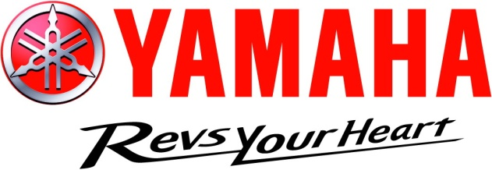

YAMAHA YMF R3 CUP 2019 Bonus Programme
 | 1st  Outright | 2nd Outright | 3rd Outright
Each race per Championship Round | 175 | 100 | 75
Overall place getters for each of the 5 rounds | 500 | 300 | 150
Overall Series Championship | 5000 | 3000 | 1500
Dual Championship bonus R3 Cup and 300 Supersport - $2000
R3 Cup Bikes must display all Series logos, (available from YRD)
All prize monies are plus GST if applicable. If not registered for GST simply state that on the invoice. Invoices to be forwarded to YRT, PO Box 110, Mt Evelyn 3796 or yrd@bigpond.com within 2 weeks of race result. Invoices must either contain an ABN or a statement asserting that motorcycle sport is the rider’s hobby. (A template is available for guidance)

